|  |
| --- |
| Neusoft Corporation |
| Project Proposal |
| ***For China TV on S40***  October 22, 2010 |

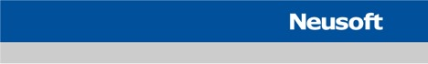

Table of Contents

Index of Tables 4

Index of Figures 4

Proposed Team Organizations 5

Team Competence 5

Draft Schedule 5

Workloads Estimation 5

WBS & Timeline 6

Pricing 7

T&M Pricing 7

Lead Product 7

Copy Products Services 7

Terms and Conditions 9

Answer to questions in the RFQ 9

Questions presented in section 3 9

Link to Supplier’s web pages 10

Link to screenshot to the licensed product 10

list of other customers using the Licensed Product 10

Open source items included in the Licensed Product 11

variation between requirement and proposal 11

Contract Status & Applicable Price List 11

Frame Agreement(s) 11

Price List 11

Draft Project Plan 11

Project Scope 11

Planning Tools 12

Travelling Plan 12

Training Plan 12

Risk Analysis 12

Risks 12

Quality Plan 13

Quality Requirements 13

Quality Management & Organization 13

Process and Project Management 14

Agile Scrum Process 14

Nokia Standard Tools 15

Process and Project Management Practices between Nokia and Neusoft 15

Relevant Project References 17

Mobile TV DVB-H 17

CMMB/MBBMS Development 17

Usage of Open Source 17

# Index of Tables

Table 1 Team Competence 5

Table 2 Lead Product Workload Estimation 6

Table 3 WBS & Timeline for Lead Product 7

Table 4 Lead Product T&M Price List 7

Table 5 Option 1 Full On-demand mode 8

Table 6 Copy product Estimation 8

Table 7 Fixed Price for Copy Product 8

Table 8 Tools & SW Status 15

# Index of Figures

Figure 1 Quality Organization 13

Figure 2 Quality Management 14

Figure 3 Scrum Process 14

Figure 4 Process and Project Management Practices 16

# Proposed Team Organizations

## Team Competence

The resources listed below are for project kick-off, additional resources will be added during project execution. And actual resources might change with guarantee of similar competences.

|  |  |  |
| --- | --- | --- |
| **Name** | **Role** | **Competence** |
| Lei Sun | Team Lead & Developer | QT, Android, WM, Symbian, CMMB |
| Zhao Zhe | Developer | Windows CE, Windows Mobile, CMMB |
| Song Lixin | Developer | VC++, Windows, Linux, CMMB |
| Yang Ning | Developer | Windows CE, Windows Mobile, CMMB |
| Yu Ling | Developer | Symbian, Android, CMMB |
| Ma Chuan | Developer | C++, LUA, XML, SQLite, Internet TV |
| Zou Haoran | Developer | Brew, C++, CMMB |
| Wang Dayong | Developer | C++, Android, CMMB |
| Wang Jian | Developer | C++, JAVA, Sound device, Multimedia |
| Xue Ming | Developer | C++, Android, CMMB, Internet TV |
| Wang Tiejun | Architect | C++, Android, Symbian, Linux, CMMB |
| Li Renhui | Testing Lead | Symbian, CMMB |
| Wang Chong | Tester | Symbian, CMMB |
| Shen Xi | Tester | Symbian, CMMB |
| Guo Xin | Tester | Symbian, CMMB |

Table 1 Team Competence

## Draft Schedule

### Workloads Estimation

#### Lead Product

The workloads is based on the following assumptions:

1. The target device is full touch only.
2. On-demand resources are reserved for integration work until product hits market, as project dependencies are not clear, so additional resources may be needed during project execution.
3. UI development shall be in Neusoft Shenyang office using simulator provided by Nokia, most middleware, engine development, and integration work need to be done onsite at Nokia’s Beijing office.
4. Nokia shall provide Neusoft with SDK and related tools ready for development purposes by 1-Nov-2010.
5. Nokia shall provide Neusoft with stable target devices and related accessories by 1-Mar-2011
6. Nokia shall provide Neusoft with stable CMMB signal receiver & UAM by 1-Mar-2011
7. All UI elements will be implemented using OS’s built-in controls and styles
8. The estimation is based on CMCC “手机电视UI设计规范2.0_20100728”, “移动多媒体广播手机电视业务接口规范——手机终端与业务平台间接口分册 20100719” and “移动多媒体广播手机电视业务终端规范—手机分册2.0.0 20100714”. All the features without clear description will NOT be included in the quotation. All the features that are not able to be tested due to lack of pre-conditions (e.g. interactivity, data broadcasting due to lack of contents) will NOT be included in the quotation.
9. The proto and corresponding SDK/drivers shall be ready and stable for application development and testing purposes when delivered to Neusoft
10. Anything beyond this estimation or changes occurred in this project execution approved by Nokia will be invoiced.

|  |  |  |  |  |  |  |  |  |  |  |  |  |  |  |  |  |  |  |  |
| --- | --- | --- | --- | --- | --- | --- | --- | --- | --- | --- | --- | --- | --- | --- | --- | --- | --- | --- | --- |
|  |  | **2010** | | **2011** | | | | | | | | | | | | **2012** | | | **Total** |
| P11 | P12 | P1 | P2 | P3 | P4 | P5 | P6 | P7 | P8 | P9 | P10 | P11 | P12 | P1 | P2 | P3 |
| Fixed | Designer | 2 | 5 | 10 | 12 | 6 | 4 | 4 | 4 | 4 | 4 | 2 |  |  |  |  |  |  | 57 |
| Tester | 2 | 2 | 4 | 4 | 4 | 4 | 3 | 3 | 3 | 3 | 2 |  |  |  |  |  |  | 34 |
| On-demand | Designer |  |  |  |  | 2 | 2 | 2 | 2 | 2 | 2 | 1 | 1 | 1 | 1 | 1 |  |  | 17 |
| Tester |  |  |  |  | 2 | 2 | 2 | 2 | 2 | 2 | 1 | 1 | 1 | 1 | 1 |  |  | 17 |
|  | **Subtotal (Fixed)** | 4 | 7 | 14 | 16 | 10 | 8 | 7 | 7 | 7 | 7 | 4 | 0 | 0 | 0 | 0 | 0 | 0 | 91 |
| **Subtotal (on-demand)** | 0 | 0 | 0 | 0 | 4 | 4 | 4 | 4 | 4 | 4 | 2 | 2 | 2 | 2 | 2 | 0 | 0 | 34 |
| **Total** | 4 | 7 | 14 | 16 | 14 | 12 | 11 | 11 | 11 | 11 | 6 | 2 | 2 | 2 | 2 | 0 | 0 | 125 |

Table 2 Lead Product Workload Estimation

### WBS & Timeline

Neusoft would propose the following milestones (***note that any test case or bug due to lack of external services/support will not be counted in the stats).***

* **Lead Product**: Design Completed, wk18 2011 – Coding Completed, 2011 wk 36 Integration Completed, to reach Nokia X3 standard (98% pass rate, 100% run rate, no critical issues), wk 04 2012 – Product released
* **Copy products**: Milestones will have to be discussed later when project information is clear.

|  |  |  |  |  |  |  |  |  |  |  |  |  |  |  |  |  |  |  |
| --- | --- | --- | --- | --- | --- | --- | --- | --- | --- | --- | --- | --- | --- | --- | --- | --- | --- | --- |
|  | **Tasks** | **2010** | | **2011** | | | | | | | | | | | | **2012** | | |
| P11 | P12 | P1 | P2 | P3 | P4 | P5 | P6 | P7 | P8 | P9 | P10 | P11 | P12 | P1 | P2 | P3 |
| **Lead product** | OS & HW Feasibility Study | 4 |  |  |  |  |  |  |  |  |  |  |  |  |  |  |  |  |
| UI Design & Review |  | 2 |  |  |  |  |  |  |  |  |  |  |  |  |  |  |  |
| Porting Guidelines |  | 1 |  |  |  |  |  |  |  |  |  |  |  |  |  |  |  |
| MBBMS Design |  | 1 |  |  |  |  |  |  |  |  |  |  |  |  |  |  |  |
| UAM Design |  | 1 |  |  |  |  |  |  |  |  |  |  |  |  |  |  |  |
| Test Cases Design |  | 2 |  |  |  |  |  |  |  |  |  |  |  |  |  |  |  |
| CMMB Engine Porting |  |  | 2 | 2 |  |  |  |  |  |  |  |  |  |  |  |  |  |
| MBBMS Implementation |  |  | 3 | 3 | 2 |  |  |  |  |  |  |  |  |  |  |  |  |
| Play Engine Porting |  |  | 2 | 2 |  |  |  |  |  |  |  |  |  |  |  |  |  |
| UAM Development |  |  |  | 2 | 1 | 1 |  |  |  |  |  |  |  |  |  |  |  |
| UI Development |  |  | 3 | 3 | 3 | 3 |  |  |  |  |  |  |  |  |  |  |  |
| Incremental Testing |  |  | 4 | 4 | 4 | 4 |  |  |  |  |  |  |  |  |  |  |  |
| Integration Testing |  |  |  |  |  |  | 3 | 3 | 3 | 3 |  |  |  |  |  |  |  |
| Integration Bug fixing |  |  |  |  |  |  | 4 | 4 | 4 | 4 |  |  |  |  |  |  |  |
| PA Testing |  |  |  |  |  |  |  |  |  |  | 2 |  |  |  |  |  |  |
| PA Bug Fixing |  |  |  |  |  |  |  |  |  |  | 2 |  |  |  |  |  |  |
| Maintenance - Bug Fixing |  |  |  |  | 2 | 2 | 2 | 2 | 2 | 2 | 1 | 1 | 1 | 1 | 1 |  |  |
| Maintenance - Testing |  |  |  |  | 2 | 2 | 2 | 2 | 2 | 2 | 1 | 1 | 1 | 1 | 1 |  |  |

Table 3 WBS & Timeline for Lead Product

# Pricing

## T&M Pricing

The price consists of 2 parts: a fixed sum fee for lead product development and two different options for copy products.

### Lead Product

We would offer the ***ERUO 328,900.00*** for lead product. Hourly rate is 13 Euro and working days per month is 22.

|  |  |  |  |  |  |
| --- | --- | --- | --- | --- | --- |
|  | **Resources** | **Man Months** | **Work Days/Month** | **Hourly Rate (Euro)** | **Total** |
| **Lead Product** | **Fixed** | 91 | 22 | 13 | 208208 |
| **On-demand** | 34 | 22 | 13 | 77792 |
| **Subtotal** |  |  |  | 286000 |
| **Travel Expenses & OT** |  |  | 15% | 42900 |
| **Total** | | | | **328900** |

Table 4 Lead Product T&M Price List

### Copy Products Services

For copy products, we offer 2 options: full on-demand mode and subscription mode

#### Option 1: Full on-demand Mode

Based on our fixed hourly price, Nokia can request certain services for a determinable time according to the project needs. It is cost-effective and avoid a certain amount of risks.

|  |  |
| --- | --- |
| Services | Hourly Price (Euro) |
| UI Customization | 13 |
| Support | 13 |
| Maintenance | 13 |

Table Option 1 Full On-demand mode

Note:

* As the resources needed varies from project to project, the actual quotation need to be made case by case.
* Upgrades of Licensed products are free of charge, but the integration, maintenance and support that make the whole product work shall be charged according to actual resources usage with the prices listed above.
* Monthly payment is required

#### Option 2. Fixed Price

The one sum price for each copy product is ***Euro 36608***, and the invoice will be sent on the following milestones:

* M1: Full testing completed
* M2: PA Testing passed
* M3: Product released

For each copy product, the workloads (see Table 6 Copy product Estimation) are estimated on the following assumptions:

1. Full touch UI from lead product will be used without changes
2. The life cycle of each copy product is around 6 months. If the project lifecycle is over 6 months and the project needs resource after first 6 months, a new quotation is required.
3. Each copy product will share the same hardware and software as the lead product
4. No new requirements for copy products
5. All protos and related accessories shall be ready when project kicks off
6. Resources are reserved for bug fixing, testing, build manager tasks, integration tasks, and fault manager tasks

|  |  |  |  |  |  |  |  |
| --- | --- | --- | --- | --- | --- | --- | --- |
|  | **1** | **2** | **3** | **4** | **5** | **6** | **Total** |
| Designer | 2 | 1 | 1 | 1 | 1 | 1 | 7 |
| Tester | 4 | 1 | 1 | 1 | 1 | 1 | 9 |
| **Total** | 6 | 2 | 2 | 2 | 2 | 2 | 16 |

Table Copy product Estimation

|  |  |  |  |
| --- | --- | --- | --- |
| **Man Months** | **Work Days/Month** | **Hourly Rate (Euro)** | **Total** |
| 16 | 22 | 13 | 36608 |

Table Fixed Price for Copy Product

## Terms and Conditions

Besides the assumptions mentioned in Lead Product Workloads Estimation section and Copy Products pricing section, terms and conditions are as follows

1. The lead product and copy product share the same hardware and software
2. No UI changes on the copy product, just maintenance and testing efforts
3. Each product has its own separate development and testing team
4. The copy product will kick off after the lead product
5. The UI will be implemented in a simple way, instead of a complex UI using customized components
6. Nokia shall provide necessary communication or process tools (Cwiki typically), accounts for all team members
7. Third-party tools that need licenses may not be available at Neusoft, and Nokia shall provide the tool if needed
8. Nokia shall clarify confusions about the Nokia’s specific requirements.
9. Nokia shall be responsible for providing custom UI design, graphic design and localization strings.
10. Nokia shall be responsible for delivering the proto to Neusoft office.
11. Nokia shall be responsible for SIM card and data/voice fees, travel expenses, and the extra cost for overtime work during project execution.
12. Neusoft owns the IPRs of Middleware and Engine, Nokia owns the IPRs of UI.

# Answer to questions in the RFQ

## Questions presented in section 3

1. Experience with CMMB and MBBMS? References to earlier projects and track record?
   1. Neusoft has established CMMB and MBBMS product lines for 4 year since the very beginning of CMMB emergence. Till now, we have successfully implemented CMMB/MBBMS client and middleware on various of platforms such as Symbian (including S60 3rd, 3rd FP1, 3rd FP2, 5th and Symbian^3), Windows Mobile ( 6.1, 6.5) and Android (2.1). We are cooperating with Nokia on 2 S60 TD-SCDMA products right now.
2. Experience with other MobileTV systems e.g. DVB-H/T, ISDB-T, T-DMB etc. References to earlier projects and track record?
   1. Neusoft has set up a maintenance team working for S60 DVB-H since 2009, the team grows to about 20 engineer at present. Please see project reference for details.
3. Experience with S40 native implementation. References to earlier projects and track record?
   1. No, Neusoft did not get involved in S40 native application development.
4. Competences available for MobileTV work and S40 programming?
   1. For Mobile TV, we have strong competence on CMMB/MBBMS and DVB-H.
   2. For S40, all developers on the team have strong competence on ANSI C and OOP experience, which is the solid ground to start S40 programming.
5. Relationship with China Mobile and access to utilize China Mobile laboratory for testing purposes?
   1. Neusoft has been a vendor and partner of China Mobile since 2000. The projects collaborated include both outsourcing and co-development.
   2. Yes, Neusoft has the access to CMCC’s lab.
6. Experience and capability to do field testing for CMMB/MBBMS?
   1. The testing team has over 4 years of experience on CMMB field testing and over 2 years of experience on MBBMS field testing.
   2. All testers have extensive experience in mobile testing domain and are familiar with Nokia process tools and working style.
7. Resource allocation plans and competence of the resources?
   1. Please see for details
8. Proposed SW architecture for S40 CMMB implementation?
   1. Please see architecture document attached
9. Proposed time schedule and intermediate milestones for S40 CMMB implementation (Nokia target for SW ready for type approvals is November P11 2011)
   1. Lead Prodcut: Wk 52 2010 – Design Completed, wk18 2011 – Coding Completed, wk 36 2011– Integration Completed, wk 04 2012 – Product released
10. Supplier access for latest CMMB and CMCC specifications?
    1. Yes, Neusoft has the link to CMCC and can obtain the latest spec.
11. Supplier own test equipment and test setup to verify CMMB and MBBMS?
    1. Yes, Neusoft owns the transmitter equipment for CMMB. There is no equipment available in the market for testing MBBMS yet as far as we know.
12. Supplier secure data system (FTP etc.) for exchanging large documents and code?
    1. We have separate server room for Nokia and have dedicate SVN server for configuration management, redmine server for project management, document management and issue tracking. And a trusted FTP server has been set up for S60 projects to download the SDKs and tools, the server can be shared with S40 project team if needed.

## Link to Supplier’s web pages

Company web site: <http://www.neusoft.com>

CMMB Bluetooth Adapter: http://www.neusoft.com/soft_service/product/1399/

## Link to screenshot to the licensed product

<http://www.neusoft.com/soft_service/product/1399/>

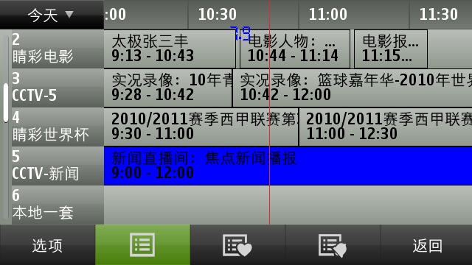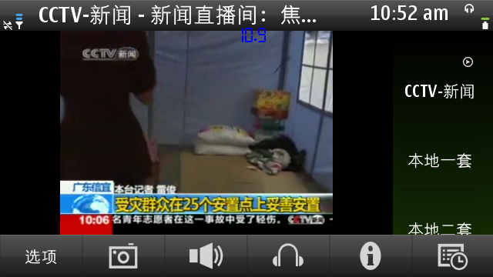

## list of other customers using the Licensed Product

* Nokia <http://www.nokia.com>
* Semiwell: <http://www.semiwell.com.cn>

## Open source items included in the Licensed Product

N/A

## variation between requirement and proposal

N/A

# Contract Status & Applicable Price List

## Frame Agreement(s)

Neusoft and Nokia reached **FRAME AGREEMENT FOR SOFTWARE DEVELOPMENT SUBCONTRACTING** on 1st May, 2005. Please see attachment  for details.

## Price List

Neusoft and Nokia reached the price list agreement which is under the **FRAME AGREEMENT FOR SOFTWARE DEVELOPMENT SUBCONTRACTING** between **NOKIA CORPORATION** and **NEUSOFT CORPORATION** dated 1st May, 2005. And the price list is valid from 2010.01.01 to 2010.12.31. Please see attachment  for details.

# Draft Project Plan

## Project Scope

Neusoft would propose that the 1st release might target at the following:

*Environments*:

* Target Platform: S40 version
* Target Device: Lead Product ?? with Full Touch
* Development Tool: Slickedit

*Features*:

1. Aligned with CMCC specs: “手机电视UI设计规范2.0_20100728”, “移动多媒体广播手机电视业务接口规范——手机终端与业务平台间接口分册 20100719” and “移动多媒体广播手机电视业务终端规范—手机分册2.0.0 20100714”
2. All the features that are not able to be tested due to lack of pre-conditions (e.g. interactivity due to lack of contents) will NOT be included in the quotation.

*Quality*:

Aligned with Nokia’s quality standards

## Planning Tools

1. **Microsoft Excel**: Neusoft shall provide the tool while Nokia shall provide the Scrum related templates if required.
2. **Microsoft Visio**: Neusoft shall provide the tool for internal project related planning and UI designing.
3. **Accept 360**: Nokia shall provide the tool.
4. **Microsoft Project**: Neusoft shall provide the tool for internal project planning & scheduling for internal uses.
5. **Adobe Acrobat**: Neusoft shall provide the tool for delivering the UI spec and design

## Travelling Plan

The travelling is not needed for this specific project unless specific testing/environment setting up/training is required to be carried out.

## Training Plan

NEED S40 documentation to come up with a training plan.

## Risk Analysis

### Risks

|  |  |  |
| --- | --- | --- |
| Risks | Probability to take place | Actions |
| CMMB Receiver & UAM driver are supplied by other vendors, the project schedule might get delayed by external dependency. | High | Reserve some resources for unexpected delays, meanwhile a mock implementation needs to be created in order to get the remaining parts aligned with schedule. |
| Proto application takes time, the team may face the difficulty with shortage of phones and headsets | High | Need Finland’s support to get enough hardware. |

## Quality Plan

### Quality Requirements

Neusoft would like to propose the following quality goals

1. No crashes or show stoppers
2. Passed Nokia Ovi QA criteria

### Quality Management & Organization

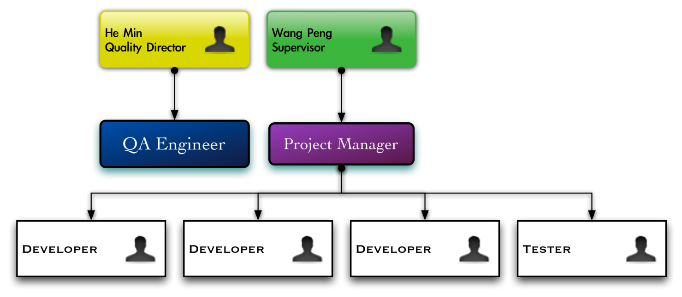

Figure 1 Quality Organization

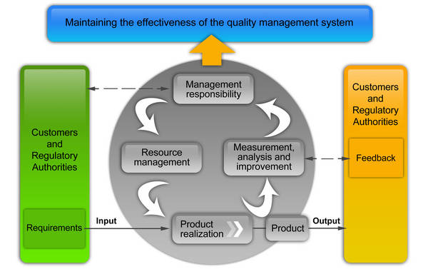

Figure 2 Quality Management

# Process and Project Management

## Agile Scrum Process

Neusoft has followed the Agile Scrum Process for years and all the testers and developers are familiar with the process.

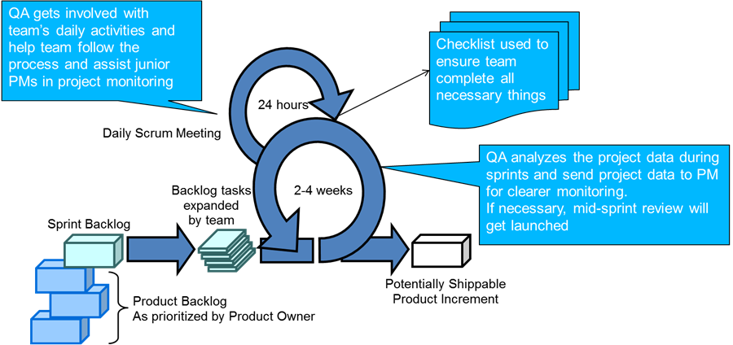

Figure 3 Scrum Process

## Nokia Standard Tools

Neusoft has been working with Nokia since 2005; therefore all the resources are quite familiar with TSW/QC/Synergy/CWiki/LN.

|  |  |  |
| --- | --- | --- |
| **Tools/SW** | **Status** | **Owner** |
| **Synergy Client** | Ready | Neusoft |
| **Synergy DCM** | Pending | Nokia |
| **IDE** | Pending | Nokia |
| **S40 SDK** | Pending | Nokia |
| **TSW Access** | Pending | Nokia |
| **QC Access** | Pending | Nokia |
| **Cwiki Access** | Pending | Nokia |

Table 8 Tools & SW Status

## Process and Project Management Practices between Nokia and Neusoft

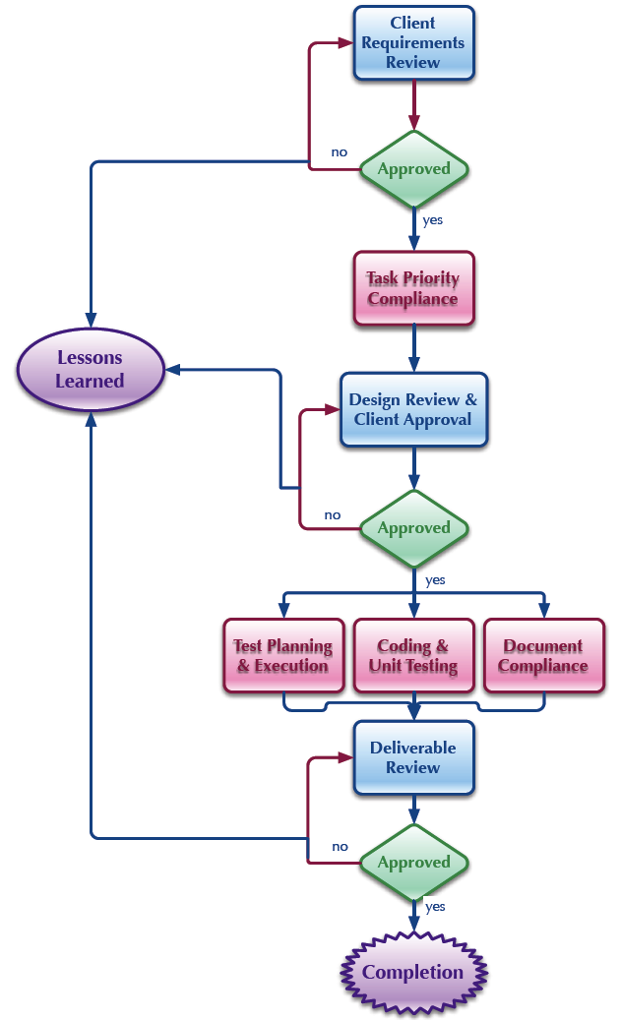

Figure 4 Process and Project Management Practices

# Relevant Project References

## Mobile TV DVB-H

Project name: Mobile TV ( S60 DVB-H) Maintenance

Customer: Nokia AE

PM name: Chuang Yu

Team size: 20 Developers

Effort: 150 Man Months

Period: 1.1.2009-now

SW dev. model: Scrum

Activities: UI & Middleware maintenance

Technologies: S60 UIFW, ECOM, Video/Audio Streaming/Decoding

OS / Platform: S60 3.2.x, 5.0

Description: Maintaining Mobile TV Application on S60 platform, including both UI layer and Midware / Engine layer (IPDC). Maintaining a DVBH Lab. Implementing some UI layer features.

## CMMB/MBBMS Development

Project name: China TV

Customer: Nokia DSW

PM name: Huang Guoqing

Team size: 20

Effort: 120 Man Months

Period: 1/10/2009 - now

SW dev. model: Scrum

Activities: Development

Technologies: S60 3.x, 5.x, TB 9.2

OS / Platform: Symbian / S60

Description: Implement CMMB/MBBMS on CMCC’s TD-SCDMA network.

# Usage of Open Source

Open source code may be used in this project on the condition that Nokia and Neusoft agree.